**SYS INT MODULE**

**-Aryan Kayande**

**Checkpoint 1 : -**

1. Data Types of signals :

Camera Node - YOLO : Image in the form of 3D array: height width and colour. The output of YOLO are the bounding boxes around the cones seen in the left image. This contains 3 types of information : coordinates(of the centre) and the size of the bounding box, class of the cone(yellow, blue or orange) and confidence. This also contains the timestamp indicating when the image was captured and at what time does the bounding box correspond to. Then, we identify 7 key points on the cone which are then “propagated” to the right image using Patch Regression. Based on these key points, we also find the bounding boxes of the cones in the right image. Both of these bounding boxes are passed on to the triangulation part, where we find the depth of each cone and the corresponding timestamp. The final output of all this is in the form of an array which consists of the cone position and its class. This is passed on to SLAM. SLAM also takes in velocity(and its corresponding timestamp) as its input, and gives map and car position as output. Map consists of global coordinates of all the cones(as well as their classes) in an array format. It also gives out the global position of the car as its output(wrt to a reference point). This, along with the velocity(and timestamp) is the input to PPC, which predicts the expected throttle and steering and passes it onto the CAN model(more on this later), which again passes the yaw to SLAM and the cycle continues.

1. Problems :

i) Time lag - as seen above, timestamps are involved in almost all of the signals, but sometimes, the timestamps of some signals may not match sometimes. This is called time lag. Several methods can be used to solve this problem. For example ros time synchronisation, or ros message queues. Ros messages queues are used to store messages between the nodes, when the sender is producing messages faster than what the receiver can process.

ii) DIfference in frequency - some methods to solve this error include Interpolation, Downsampling/Upsampling, time synchronisation etc. Interpolation techniques are used to bridge gaps between irregularly sampled data points to create a more uniform and consistent stream of messages. Various libraries like sensor_msg and tf2 can be used for the same.

**Checkpoint 2 -**

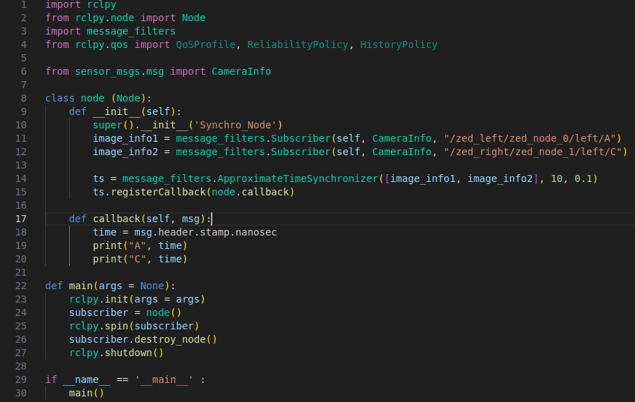

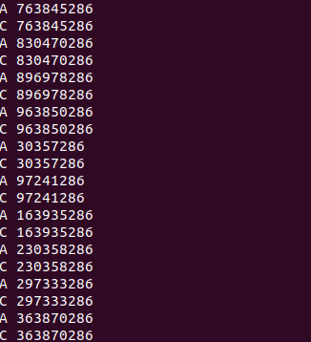

Here’s the code and the result on the terminal.

**Checkpoint 3 : -**

**CAN : -**

CAN stands for Controller Area Network, which is a network protocol more specifically, it is a multi-master serial communication bus with high speed(offers up to 1 Mbit/sec speeds) and high noise-immunity features. It is a broadcast type of bus, which means it cannot send data from point-to-point, instead it broadcasts the message over the network and thus all devices can hear the transmission. CAN uses differential signals for transmission, where 2 different complementary signals are used and their difference is calculated to measure the actual signal. 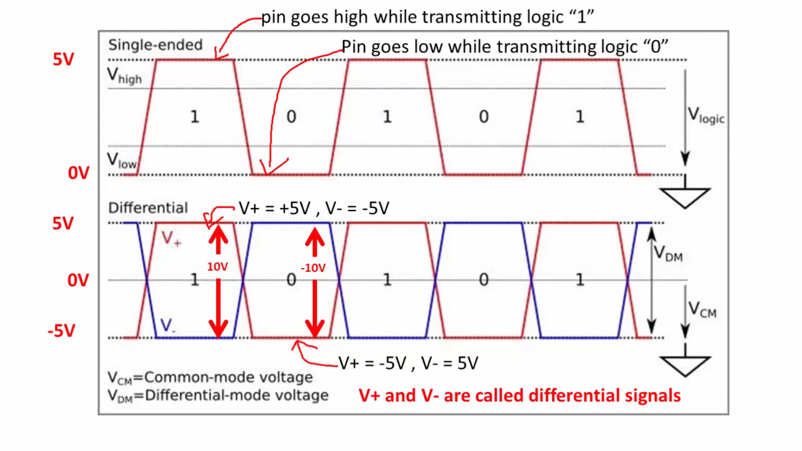

In the above image, in normal signal transmission, +5V indicates logical 1 and 0 V indicates logical 0. However, in the Differential signalling, +10V indicates logical 1 and -10V indicates 0. CAN uses 2 signals namely H and L, where the difference of H and L is taken as the actual signal. Now, while transferring logical 0 and 1, the CAN bus can be in 2 states: dominant and recessive :

